PROFESSIONAL BASKETBALL PLAYERS

A basketball player is an athlete who plays the game of basketball. Basketball players can play a variety of positions such as point guard, shooting guard, small forward, power forward, or center. These athletes must be good ball-handlers and be able to shoot,pivot,dribble,and pass during a game.

SIMILAR WEBSITES

<https://www.wnba.com/> They show similar video, stats, and pictures

<https://www.nfl.com/> They show similar video, stats, and pictures

WEBSITE PURPOSE AND GOALS

PURPOSE

The purpose of a professional basketball player are playing hard, in games and practice and doing their best for their team.

GOAL

The goal of a professional basketball player is make money, get a NBA ring

* Make a page on Sign in and Sign out
* Make a page on basketball players
* Make a page on stats
* Make page on advertisement
* Make a page on video and pictures

MILESTONES

* Sign in and Sign out
* Create an Account
* Put your Email in for any advertisement
* You would Scroll to see the stats of a player
* Click on a page to see the Gallery

METRICS

* NBA plates use wearable technologies to track their health,
* Avoid injury,and track their fatigue levels.

ANALYTICS TOOLS[https://www.quora.com/What-are-the-best-metrics-to-evaluate-basketball-players-for-your-fantasy-tea](https://www.quora.com/What-are-the-best-metrics-to-evaluate-basketball-players-for-your-fantasy-team)

<https://bleacherreport.com/articles/2793954-metrics-101-the-nbas-goat-at-every-position>

SITE MAP

<https://www.gloomaps.com/aZXfGXWA4Z>

WEBSITE CONTENT: TEXT AND IMAGES

TEXT

* Awareness “Having a sense of awareness about the game.”
* Strong Mind
* Determination

IMAGES

<https://www.istockphoto.com/photos/professional-basketball-player>

<https://www.gettyimages.com/photos/nba-pro-basketball>

Created by VisualGPS iniInsights

<https://depositphotos.com/stock-photos/professional-basketball-player.html?utm_source=google&utm_medium=cpc&utm_campaign=DP_USA_EN_Image_DSA&utm_term=>

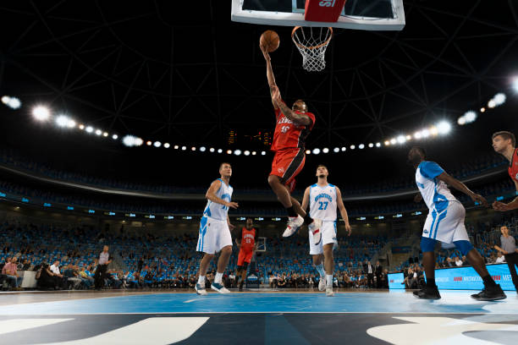

Create by simonkr / Credit Getty Images